Website PlantNest

Report project

| Team2210m | |
| --- | --- |
| Group Member | Nguyễn Hữu Dũng(leader)  Trần Thành Đạt  Đinh Doanh Việt  Trần văn Tiến  Bùi Mạnh Hùng |

Table of Contents

1. Problem Definition 3

i. Introduction 3

ii. Implementation Environment 3

User Stories 3

1.2 Admin 4

i. Login/ Logout 4

ii. Manage Plant Categories 4

iii. Manage plants/ Accessories 4

iv. Manage Users 4

v. Manage “My profile” 4

vi. Change password 4

1.3 User 4

i. Login/ Logout 4

ii. Manage Profile 4

iii. View Plant Categories 4

iv. View Plants/ Accessories 4

v. Search Plants/ Accessories 5

vi. Shopping cart 5

vii. Change Password 5

2. Flowchart 5

2.1 Login 5

2.2 Register 6

2.3 Search 7

2.4 Create Product 8

2.5 Update Product 9

2.6 Delete Product 10

2.7 Add products to cart 11

2.8 Update cart 12

2.9 Update profile 13

2.10 Send feedback 14

3. Database 15

3.1 DB Relationship Diagram 15

3.2 Table Categories 15

3.3 Table User 15

3.4 Table Orders 15

3.5 Table Accessories 16

3.6 Table Carts 16

3.7 Table Order_items 16

3.8 Table Watch_lists 17

4. UI\UX 17

4.1 Login 17

4.2 Home page 17

4.3 Product site 18

4.4 About us 19

4.5 News 20

4.6 Contact us site 21

4.7 Admin site 22

4.7.1 Account management 23

**4.7.2 Order management 23**

**4.7.3 Products management 23**

**5. Summary 24**

**6.Video demo 25**

# Problem Definition

### Introduction

A simple apartment, an incredible huge villa or just a normal office , plants often lighten them and become perfect decorations for any room . For skillful gardeners to new people that start a new gardening hobby , going to the store to get the plant they wanted can be a nuisance and time-consuming . An online gardening website will be a perfect solution for that problem and allow buyers all around the world to easily buy what they want anywhere they want. There are different ways to take care of different types of plants from simple methods to much more complicated ones. This web can provide users information so that they can care for their plant in the most efficient way.Users can also buy and order relevant stuffs such as gardening tools for their own use.

To make a solution for this subject , a website called PlantNest can provide information,shopping online for any customers who have an interest in plants,gardening,...

### Implementation Environment

* HTML5
* CSS3
* Bootstrap
* JavaScript
* PHP, Laravel framework
* XamPP

# User Stories

## Admin

### Login/ Logout

### Manage Plant Categories

* List of products
* Filter, search
* Create category
* Update category
* Delete category

### Manage plants/ Accessories

* Product list
* Create product
* Search product
* Update product
* Delete product

### Manage Users

* User list
* Find,search user
* Rate , feedback

### Manage “My profile”

* Update info

### Change password

* Update Password

## User

### Login/ Logout

### Manage Profile

* Update info

### View Plant Categories

* View product’s categories

### View Plants/ Accessories

* View products’ details
* Shopping
* View relevant information, products

### Search Plants/ Accessories

* Filter , search

### Shopping cart

* View shopping cart
* Update shopping cart

### Change Password

* Update Password

# Flowchart

## Login

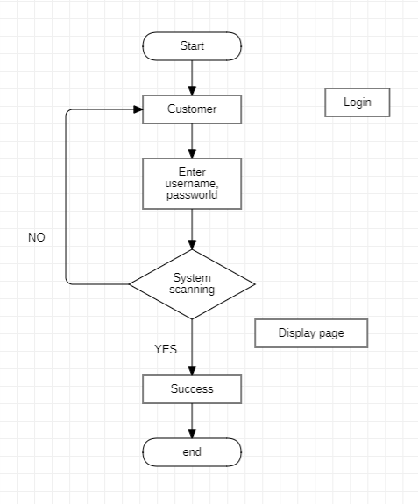

## Register

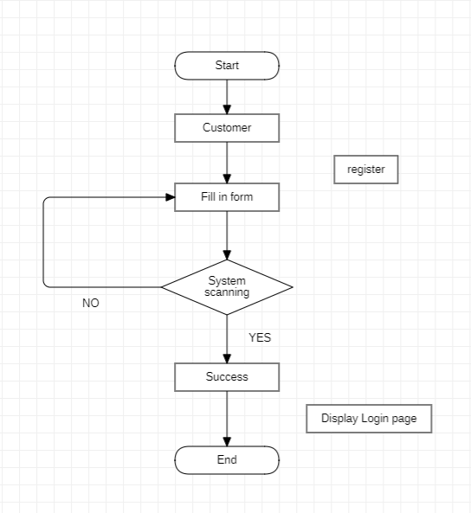

## Search

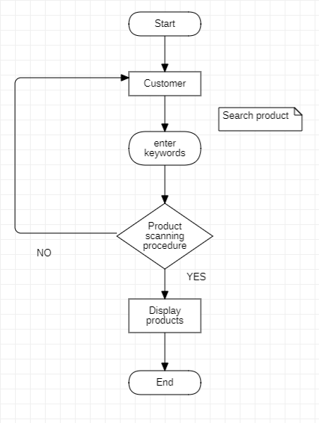

## Create Product

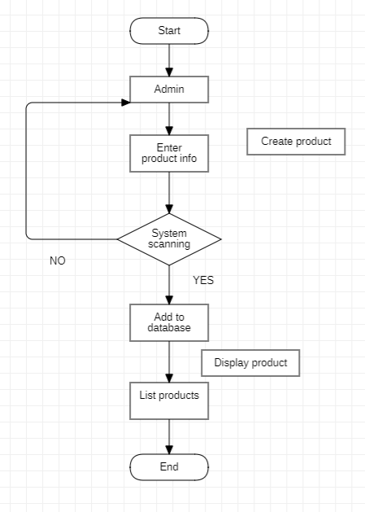

## Update Product

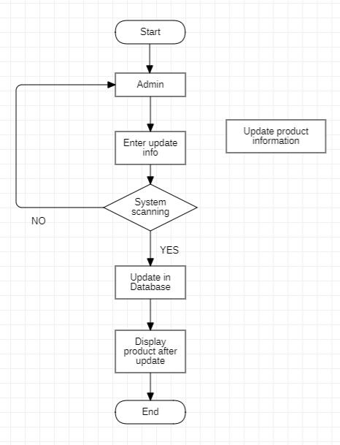

## Delete Product

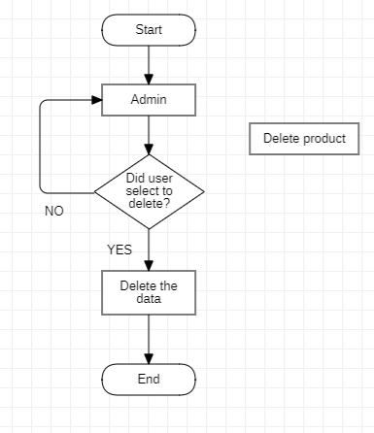

## Add products to cart

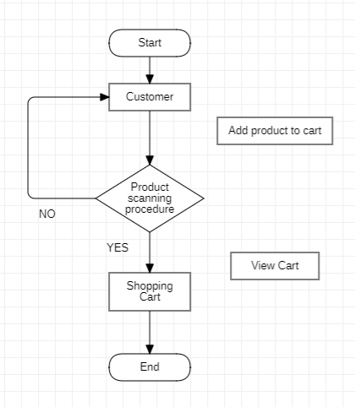

## Update cart

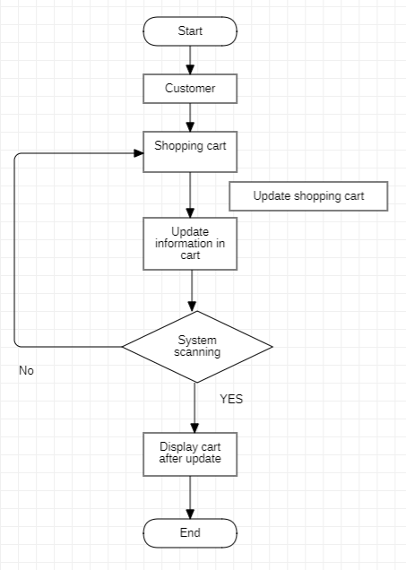

## Update profile

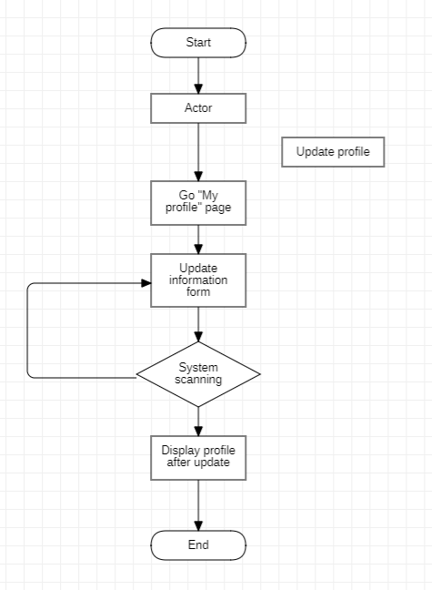

## Send feedback

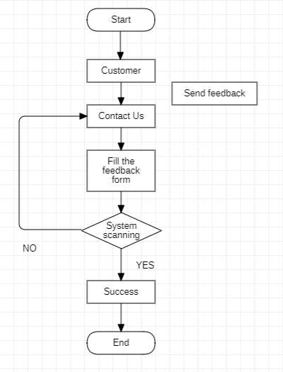

# Database

## DB Relationship Diagram

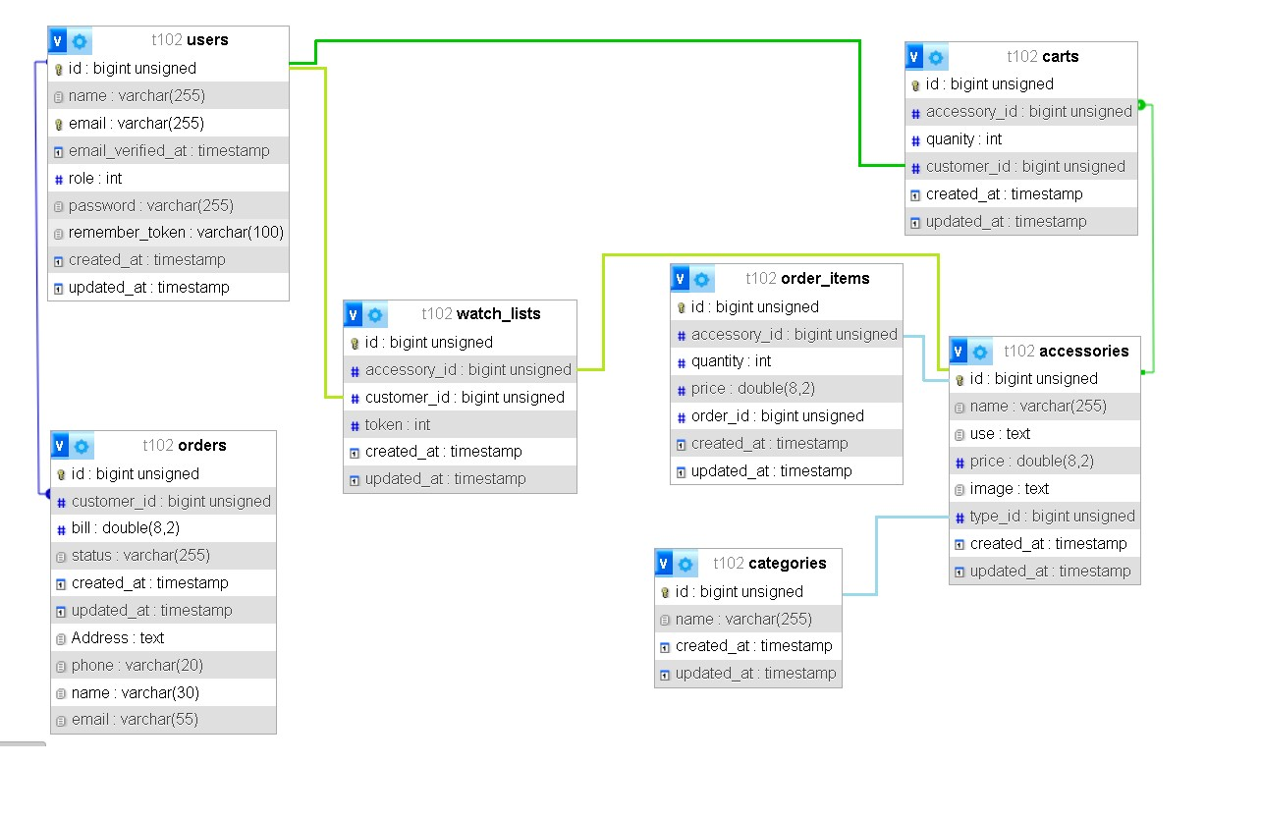

## Table Categories

| Column Name | Data Type | Constraint | Description |
| --- | --- | --- | --- |
| id | bigint(20) | PK | Primary key of the table |
| name | varchar(255) | Not null | Category name |

## Table User

| Column Name | Data Type | Constraint | Description |
| --- | --- | --- | --- |
| id | bigint(20) | PK | Primary key of the table |
| name | varchar(255) | Not null | User name, to identify a account |
| email | varchar(255) | Not null |  |
| email_verifiled_at | timestamp | Default”Null” |  |
| role | int(11) | Default”0” | 0: user  1: admin |
| password | varchar(255) | Not null |  |
| remember_token | varchar(100) | Default”Null” | Remember last login information |

## Table Orders

| Column Name | Data Type | Constraint | Description |
| --- | --- | --- | --- |
| id | bigint(20) | PK | Primary key of the table |
| customer_id | bigint(11) | FK | Foreign key reference user(id) |
| bill | double(8,2) |  | Total money |
| status | varchar(255) |  |  |
| Address | text |  | Customer’s address |
| name | varchar(255) |  | Customer’s name |
| phone | varchar(20) |  | Customer’s phone number |

## Table Accessories

| Column Name | Data Type | Constraint | Description |
| --- | --- | --- | --- |
| id | bigint(20) | PK | Primary key of the table |
| name | varchar(255) | Not null | Name of item |
| use | text |  | Description of item |
| price | double(8,2) | Not null | Price of item |
| image | text |  | Image of item |
| type_id | bigint(20) | FK | Foreign key reference categories(id) |

## 

## Table Carts

| Column Name | Data Type | Constraint | Description |
| --- | --- | --- | --- |
| id | bigint(20) | PK | Primary key of the table |
| accessory_id | bigint(20) | FK | Foreign key reference accessory(id) |
| quantity | int(11) |  | Quantity of item |
| customer_id | bigint(20) | FK | Foreign key reference user(id) |

## 

## Table Order_items

| Column Name | Data Type | Constraint | Description |
| --- | --- | --- | --- |
| id | bigint(20) | PK | Primary key of the table |
| accessory_id | bigint(20) | FK | Foreign key reference accessory(id) |
| quantity | int(11) |  | Quantity of item |
| price | double(8,2) | Not null | Price of item |
| order_id | bigint(20) |  | Foreign key reference orders(id) |

## Table Watch_lists

| Column Name | Data Type | Constraint | Description |
| --- | --- | --- | --- |
| id | bigint(20) | PK | Primary key of the table |
| accessory_id | bigint(20) | FK | Foreign key reference accessory(id) |
| customer_id | bigint(20) | FK | Foreign key reference user(id) |
| token | int(20) |  | Remember |

# UI\UX

## Login

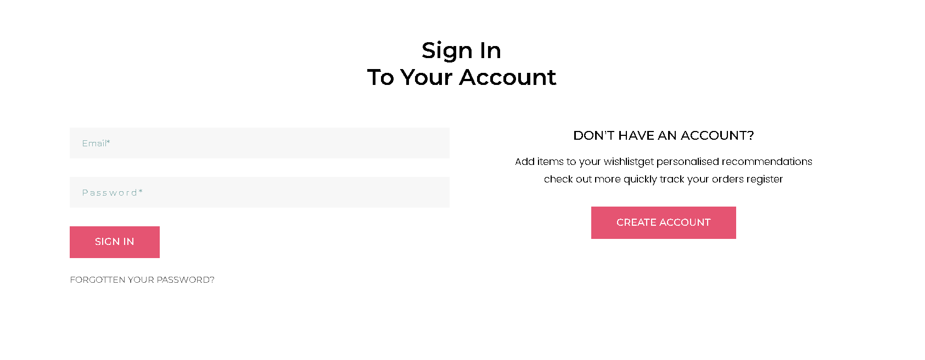

## 4.2 Home page

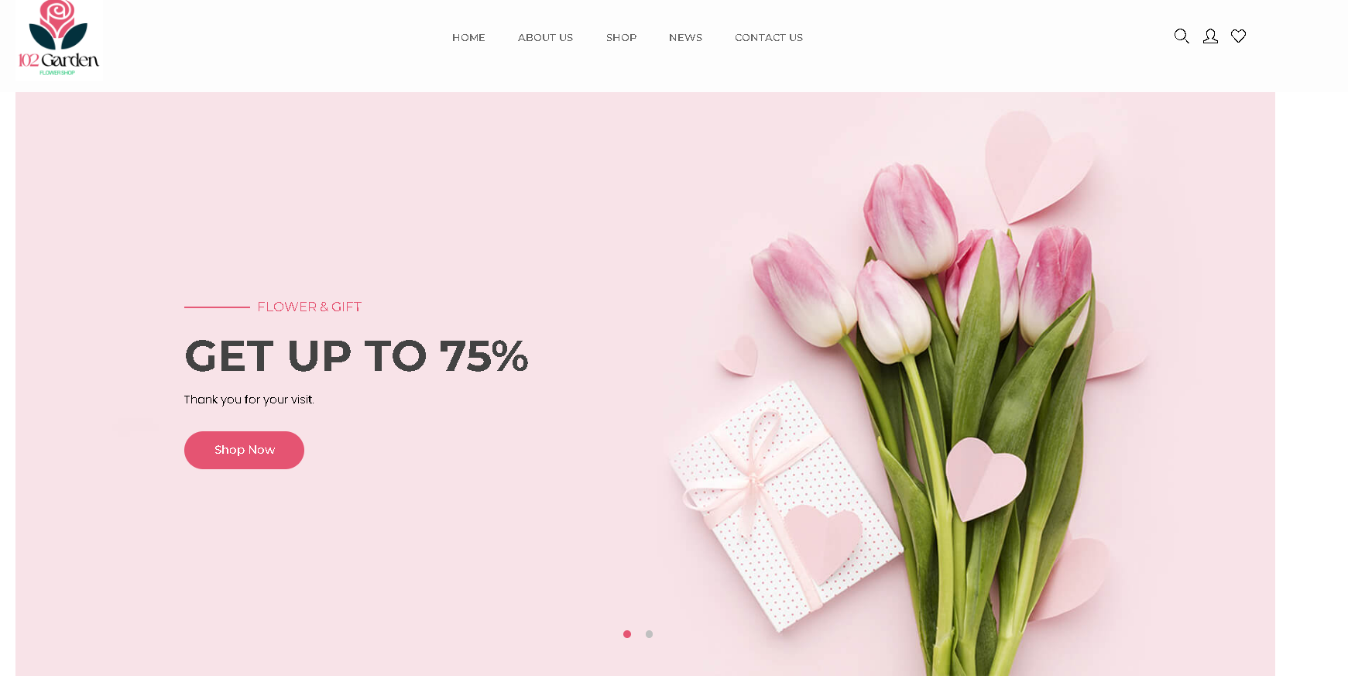

## 4.3 Product site

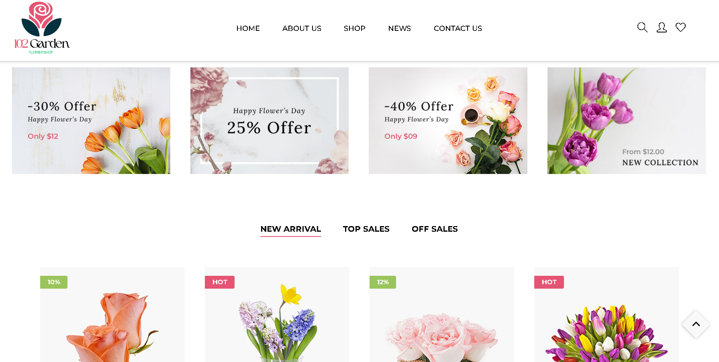

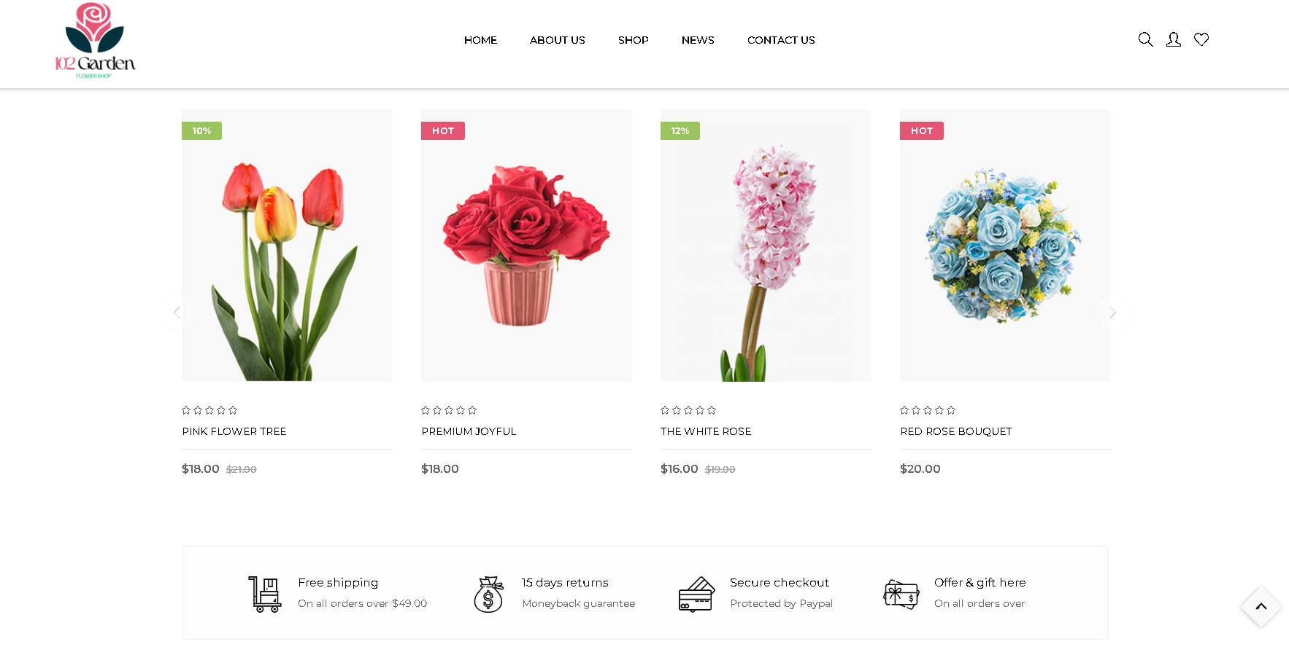

## 4.4 About us

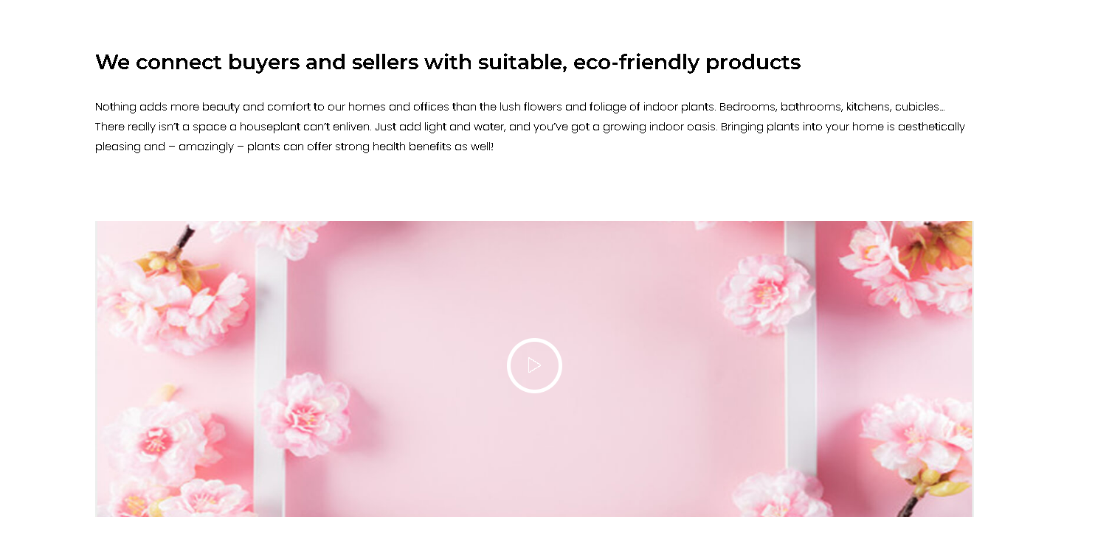

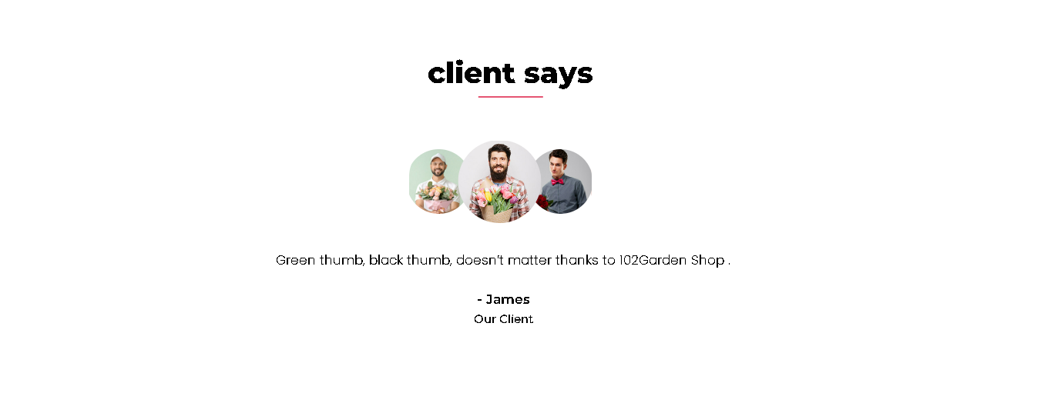

## 4.5 News

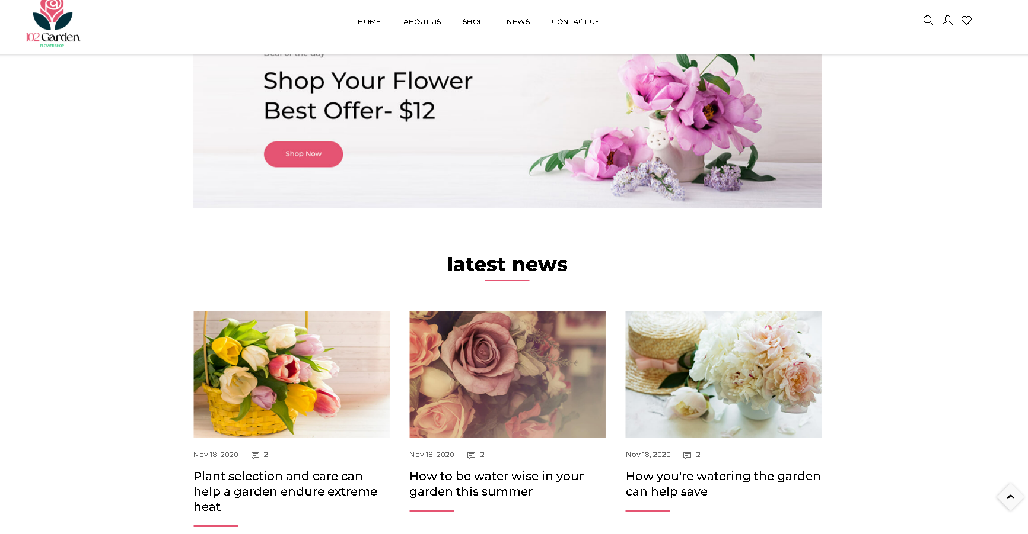

## 4.6 Contact us site

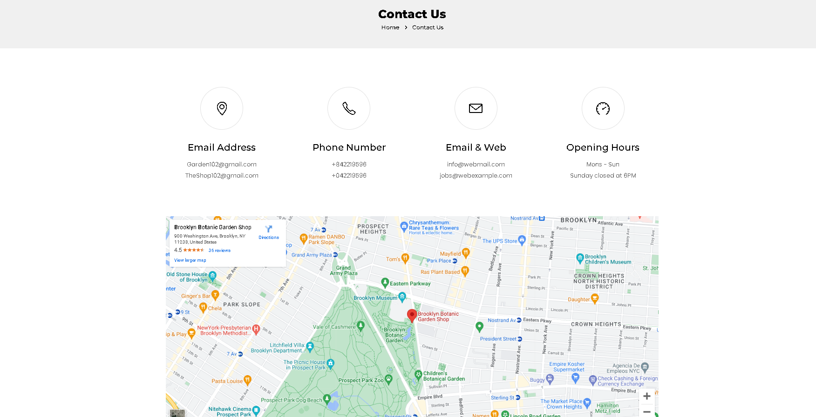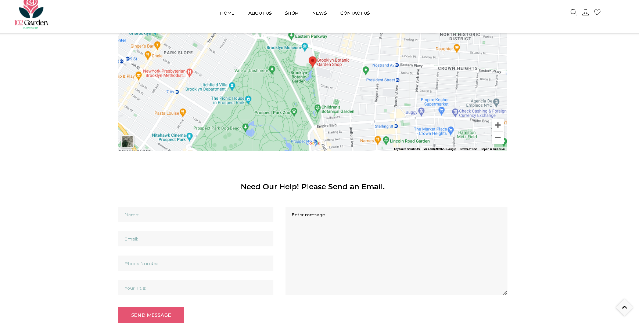

## 

## 4.7 Admin site

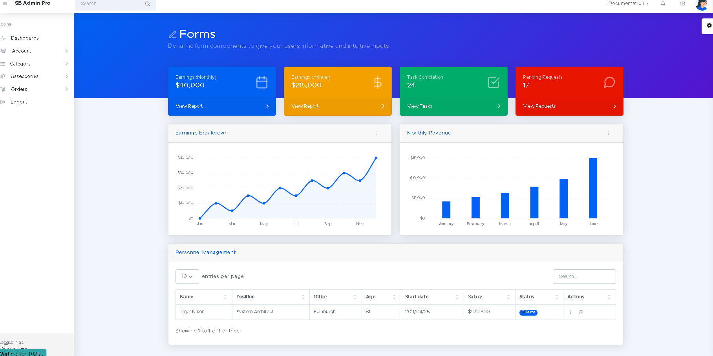

### 4.7.1 Account management

# 

# 

# 

# 

# 

### 4.7.2 Order management

# 

# 

### 4.7.3 Products management

# 

# 5. Summary

Pros :

- Can do most basic stuff a normal shopping website can do

- The web design is clear and user friendly

- Complete log in / log out ( as user and admin )

- Filter products, search products

Cons:

- There are still some flaws such as : sometimes wrong navigation , some pages are still hard code ,... But we are trying our best to improve that

- Checkout malfunction